Game Design Document

Fill up the following document

1. Write the title of your project.

-A Tour To Space

1. What is the goal of the game?

* The goal of the game is that the playing character should escape the aliens and collect all the fuel tanks which will increase the PC points

1. Write a brief story of your game.

-An astronaut named Ben is stuck in the space with a lot of aliens and not much fuel is left in his spaceship’s tank so we have to help him escape the aliens using arrow keys and collect the fuel tanks to make him reach his destination as soon as possible!

1. Which are the playing characters of this game?

* Playing characters are the ones who respond to the user based on the input from the user.
* Cars, monkeys, dinos, wizards, etc., are the playing characters in the game.

|  |  |  |
| --- | --- | --- |
| Number | Character Name | What can this character do? |
| 1 | Ben – The Astronaut | He’s riding his spaceship |
| 2 |  |  |
| 3 |  |  |
| 4 |  |  |
| 5 |  |  |
| 6 |  |  |
| 7 |  |  |
| 8 |  |  |

1. Which are the Non-Playing Characters of this game?

* Non-Playing characters are the ones that don't have an action or behavior when the user interacts with the game.
* Hurdles, stones, bananas, coins, etc., are non-playing characters in the game.

|  |  |  |
| --- | --- | --- |
| Number | Character Name | What can this character do? |
| 1 | Alien | Game end |
| 2 | Monsters | Game end |
| 3 | Fuel tank | Increase points |
| 4 |  |  |
| 5 |  |  |
| 6 |  |  |
| 7 |  |  |
| 8 |  |  |

Draw your imagination of this game. What does this game look like?

* Draw the game either on your computer or on paper.
* Add images of the game scenes to show each of the playing and non-playing characters at least once.

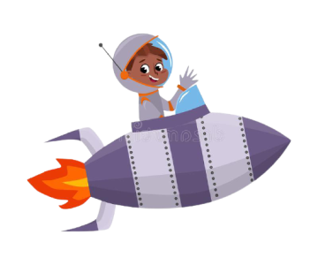

How do you plan to make your game engaging?

So , far I have thought of adding lots of obstacles , scoreboard , extra points etc. and hopefully these things will make my game more engaging